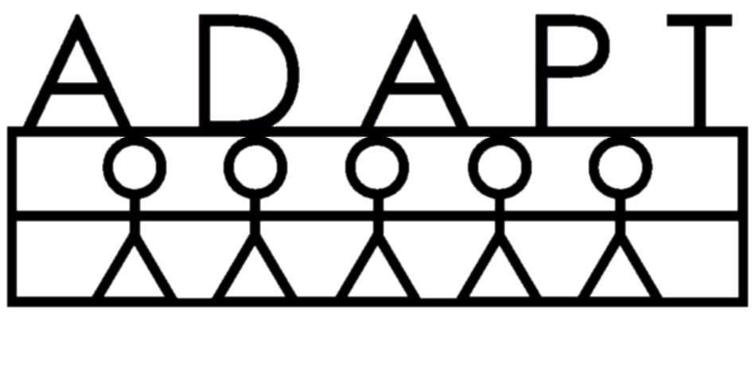

This page is to let you know some basic information about staying healthy. It also includes information about Adapt’s health & safety policies and emergency procedures.
BEHAVIORAL SERVICES
www.Adapt-FL.com

Physical & Emotional Wellness:
- Prevent disease. Wash hands thoroughly with soap BEFORE eating, treating wounds, & putting in contacts, and AFTER using the bathroom, sneezing, & blowing your nose.
- Keep yourself & your home clean: Shower daily & brush your teeth 2x daily. Don’t leave trash, dirty dishes, and food out, as these attract bugs, which bring disease.
- Prevent unwanted pregnancies: If you cannot afford or emotionally handle a child right now, get on reliable birth control. Remember it only takes once.
- Prevent sexually transmitted diseases (STD): Most birth control methods do not prevent STDs, so use a condom if you are not 100% sure that your partner is STD-free.
- Sleep well at night: Lack of continuous sleep decreases ability to focus & increases irritability/emotionality. Adults should get 8 hours, high school 8-9 hours, middle school 9-9½ hours, and elementary 10-11 hours.
- Eat a healthy diet: Eat less fast food, snack food, and fried food. Eat more fruits and vegetables. Eat when you are hungry, not because you are bored or stressed.
- Exercise your body. Spend less time sitting. Walk, jog, or bicycle several times per week. Do weight-bearing exercises to preserve bone strength.
- Exercise your brain. Reduce TV and video game time. Read books, magazines or the newspaper. Play cards or board games that make you think. Work the puzzles in the newspaper. Do a jigsaw puzzle.
- Behave in positive ways. Smile more. Compliment others. Socialize with happy people. Do things you enjoy. Talk about positive things more than negative. Remember that happiness is a choice
Adapt Health & Safety Policies:
- Abuse & neglect: All Adapt staff are legally required to report allegations or suspicion of abuse or neglect of children (age 0-17), elderly, or disabled adults.
- Danger to self or others: If an Adapt staff believes that a client or family member is likely seriously harm him/herself or someone else, the staff has a responsibility to protect that person and others from harm. In this case, more secure placement, such as hospitalization may be required on an emergency basis.
- Tobacco: The use of tobacco products is not allowed in our office or office building. Use of tobacco is permitted in designated areas away from the building entrance or stairway. Our staff are not allowed to use tobacco products in the presence of clients or their families.
- Drugs/alcohol: The use of recreational drugs or alcohol prior to or during sessions is not allowed. If an Adapt staff believes that a client or other person present for the session is under the influence of alcohol or drugs, he/she may decide to cancel the session.
- Prescription medication: If a legally prescribed medication taken prior to or during a session impairs the ability of a client or other session participant to benefit from services, the Adapt staff may decide to cancel the session.
- Weapons: Weapons of any kind are not permitted in an Adapt office. During in-home sessions, all firearms must be maintained in a securely locked area.
- Advance Directives: If you have an advance directive, please let your staff know. We will need a copy of this document for your file.
Adapt Emergency Procedures:
- Violent or threatening situations: If a client or other person present for a session becomes violent or threatening, your staff will try to verbally de-escalate him/her. If he/she is unsuccessful and the person continues to present a danger, 911 will be called. Our staff are not permitted to restrain clients or anyone else.
- Medical emergencies: If a medical emergency occurs during a session, your staff will call 911 and follow the instructions given.
- Natural disasters: If you or your staff are aware of an incoming natural disaster (e.g., hurricane, tornado, flood), check the National Weather Service and follow their instructions. If the weather service says that it is unsafe to drive, you may need to cancel and reschedule your session. If you are at our office, your staff will stay at the office with you until it is safe to leave. For home visits, your staff may need to remain at your home until the weather clears and it is safe to drive again.
- Power outage: If the electricity in the office goes out for more than 15 minutes, your session will be cancelled and rescheduled.
- Evacuation: An evacuation diagram with instructions is posted on or beside the exit door. If an evacuation of the office is necessary for safety (e.g., fire), your staff will guide you out of the office and to the meeting area (next to the dumpster). Use the stairs, not the elevator.
- Fire extinguishers & first aid kits: There is a fire extinguisher and a first aid kit in each office. Your staff will know where they are located.
If you are in crisis and your staff is not available, you can call the crisis hotline: (407) 425-2624
In the event of an emergency (danger to self or others), call 911.

